Nested Decisions

Look at this code:
raining = input("Is it raining? yes/no: ")
if raining == "yes":
windy = input("Is it windy? yes/no: ")
if windy == "yes":
print("Wear a coat.")
else:
print("Take an umbrella.")
else:
print("No rain gear needed.")

What do you think this code will display?
Click or tap here to enter text.

Run the code. Compare the result with your prediction:
Click or tap here to enter text.

Let’s investigate! Answer the questions below:
- Why is the windy question skipped when the first answer is no?
Click or tap here to enter text.

- If you answer yes to raining and no to windy, what message appears?
Click or tap here to enter text.

- Which if does the inner else belong to, and how does indentation show this?
Click or tap here to enter text.

- What route is taken for an unexpected first answer such as maybe, and why?
Click or tap here to enter text.

Nested Decisions

Look at this code:
raining = input("Is it raining? yes/no: ")
if raining == "yes":
windy = input("Is it windy? yes/no: ")
if windy == "yes":
print("Wear a coat.")
else:
print("Take an umbrella.")
else:
print("No rain gear needed.")

Use the code above to help you. After completing each challenge below, run your program to test that it works correctly. Save each completed challenge program in a new file.

Programming Challenges

Challenge 1
When [raining] is "yes", ask whether the wind is strong or light and store the answer in [wind_strength]. Display "Wear a coat." for "strong" and "Take an umbrella." for "light". Keep "No rain gear needed." when [raining] is "no". Test "yes" and "strong"; display "Wear a coat." Test "no"; display "No rain gear needed."
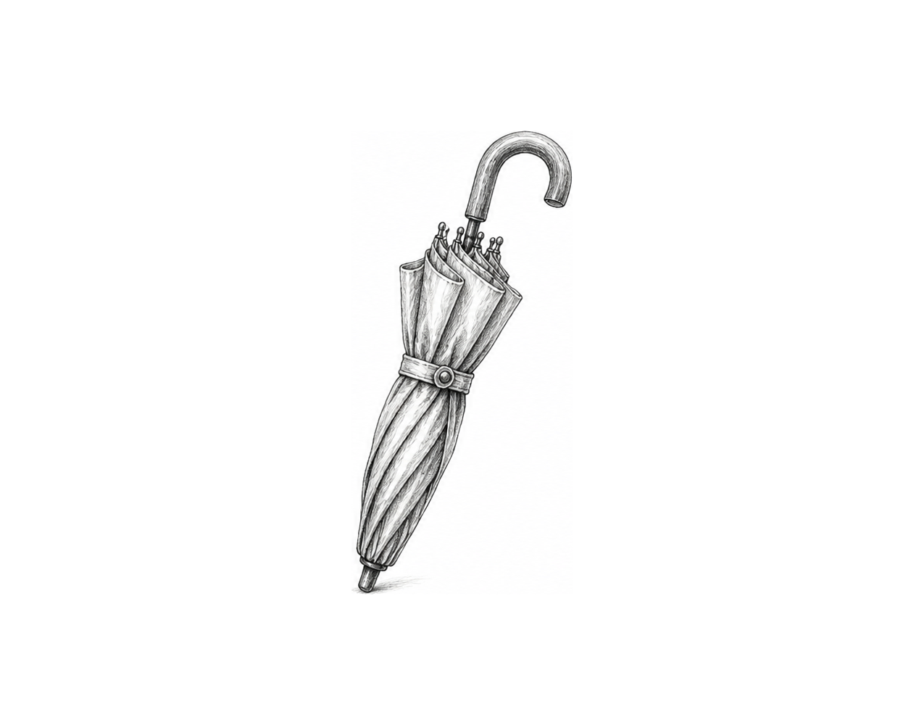

Challenge 2
Change the decision for when [raining] is "no". Ask whether it is sunny and store the answer in [sunny]. Display "Take sunglasses." when [sunny] is "yes"; otherwise display "No weather gear needed." Keep the two rain outputs unchanged. Test "no" and "yes"; display "Take sunglasses." Test "no" and "no"; display "No weather gear needed."

Challenge 3
Ask whether the visitor has a library card and store the answer in [has_card]. Use a nested if statement. When [has_card] is "yes", ask whether a book is overdue and store the answer in [overdue]. Display "Return the overdue book first." when [overdue] is "yes"; otherwise display "You may borrow a book." When [has_card] is "no", display "Apply for a library card." Test "yes" and "yes", "yes" and "no", then "no"; verify all three outputs.

Nested Decisions

Fix the code!

This code has errors! Look closely at the code to find the problems:

raining = input("Is it raining? yes/no: ")
if raining == "yes":
windy = input("Is it windy? yes/no: ")
if windy == "yes"
print("Wear a coat.")
else:
print("Take an umbrella.")

Rewrite the whole program in the box below with fixes to the errors.
Click or tap here to enter text.

After you are confident that you fixed all the errors, copy the code from the box and run it.

Did it work correctly on your first try? Did you find all the errors?
Click or tap here to enter text.

